Village of Williamsburg
Established 1796
Spring 2024 Newsletter
A Message from the Mayor…
Hello to all,

Your village council meets the 2nd Thursday of each month at 5:30. Everyone is always welcome to attend these business meetings. For those who cannot attend these regular meetings I am available typically the Wednesday before the meeting in the village offices from 7P-8P for a “chat with the Mayor opportunity. Stop in for questions and to share your thoughts. The Village of Williamsburg also has a couple of web site options www.williamsburgohio.org, is a good resource on keeping up on events, projects, Council updates, village departments and news. On Facebook (META) the group Williamsburg Council Meeting Chronicles you can find a synopsis of each regular council business meeting and various department and community activities. Here I will always post a reminder of the above mentioned “Chat with the Mayor” opportunities. Please Note, the Chronicles group is a “READ ONLY” page. You are welcome to like or share an EMOJI expression, but commenting is turned off to keep it as an information only page. If a post generates questions or concerns, contact the village offices for assistance.

We recently purchased a new mini excavator for public works to help extend the life of our 1995 backhoe with 4000 hrs. This will reduce much of the workload off the backhoe and it was half the price of a new backhoe and with a smaller footprint often allow us to keep a lane open on a street while conducting repairs. In addition. I have recommended to council to appropriate annually to fund a new backhoe in approximately 5 years and not have to sacrifice other projects to cover a 150K piece of equipment.
Meanwhile. we continue to apply for grants for various projects throughout the village. Our aging utilities infrastructure (water and sewer lines) require regular updating, and often repairs. For example, the water main we replaced out old 32 in 2022 was $76 per foot. It is now over $150 per foot. We cannot ignore these critical areas. We have been very successful in acquiring grants to provide improvements to our streets, utility systems, park and various other necessary and/or proactive projects without the burden of increased tax levies.

Please join me in welcoming Corey Herren as Williamsburg’s new police Chief. Chief Herren replaces Maggie Timmers who left to join Georgetown’s department. We wish her all the best in her new role. The chief is a critical component of any police department. Chief Herren brings with him the needed experience and personality to complement our team here in Burg.
Finally. I wish to thank Sgt. Charles Neumeyer who served as our acting chief during the transition time of securing a new chief. Job well done! We are glad you are part of our team.

Business Outlook

With each newsletter I want to highlight a local village business. This will be a brief interview/article detailing the business and what they want to share with the community. This newsletter highlights Croswell Bus Lines. Croswell has been in business since 1921 and provides motorcoach needs for groups and charters.

Our businesses are more than storefronts. Like you and me they represent families like ours. Shop Local.
Dollar General Market – Under Construction, with the recent wet weather it may be July before it opens but stay tuned. Now with produce and a full line of groceries this will be a nice convenience for the community.
Los Compadres Mexican Restaurant – awaiting some equipment and then final inspections. The hope to be open in May.
The Flour Bee- Is still working through commercial occupancy permits items but hope to be open soon.

Till next time,
Jim

Community Notes & Dates to Remember…

May 27th-Village Offices closed for Memorial Day  June 13-15-Township Junk Days  June 12th -Village Offices closed for Juneteenth.  June 21st & 22nd-June In Olde Williamsburgh Festival! | School Dates to Remember!  May 23rd-Last Day of School  May 19th-Graduation at Abrams Stadium | New pickleball courts and parking lot now open in the Community Park!  Don’t forget to visit Harmony Hill Museum!    This Photo by Unknown Author is licensed under CC BY-SA-NC  Take Time to enjoy your local Library!
News from the Village…
Village Brush Collection Schedule  On the first Monday in April, the Village will follow the curbside brush collection schedule listed below.  Area 1—1st Monday of each Month  N Eighth St. N Front St. N Fifth St.  N Fourth St. N Third St. N Second St.  Hudson St. N High St. Gay St.  Walnut St. N Broadway N Mulberry Aly.  N Dorothy Aly. N Jessamine Aly.  Area 2 – 2nd Monday of each month  S Eighth St. S Sixth St. S Fifth St.  S Broadway S Fourth St. S Third St.  S Second St. S Front St. Spring St.  Willow St. Lytle St. Wilmar St. S High St. S Mulberry Aly. S Jessamine Aly.  Area 3– 3rd Monday of each month  Paradise Ln. Moore St. Kermit Ave. Hoffman St. Curry Dr. Smith St.  Winding Trl. Coral Ct. Amber Ct.  Dawn Ct. Zachary Dr. Southwynd Trl. Julian Dr. Happy Ln. Nevels Dr.  E Main St. Kelly Dr.  Area 4—4th Monday of each month  Old SR 32 W Main St. Rose Ln.  Tollgate Rd. St. Rt. 133 All Star Dr.  Todd’s Run Foster Rd. Sally Dr.  Note: When a holiday falls on your regularly scheduled Monday, place the items out for Tuesday collection. The compost lot is also available for drop off by appointment between scheduled collection days.  As this is a labor-intensive task, this schedule will allow staff to perform the collection in a timely and effective manner. Your cooperation and patience will ensure better service for all residents and assist in more efficient use of Village resources for other projects and services. Working together will help keep our community attractive and brush-free. Please call (513) 724-6107with any questions | From the Police Department  . With warmer weather coming there will be more children playing and people out walking enjoying the nice weather. In an effort to keep our community safe please pay extra attention to the neighborhoods where children may be playing, along congested roadways where cars are parked, and views are limited and to intersections where pedestrians will be crossing.    Remember to always lock your vehicles and take any items of value inside with you. Also, a reminder to residents if you are planning a vacation, please contact our Office reference our Vacation Check Program.  It's good to be back home.  Respectfully,  Chief Herren  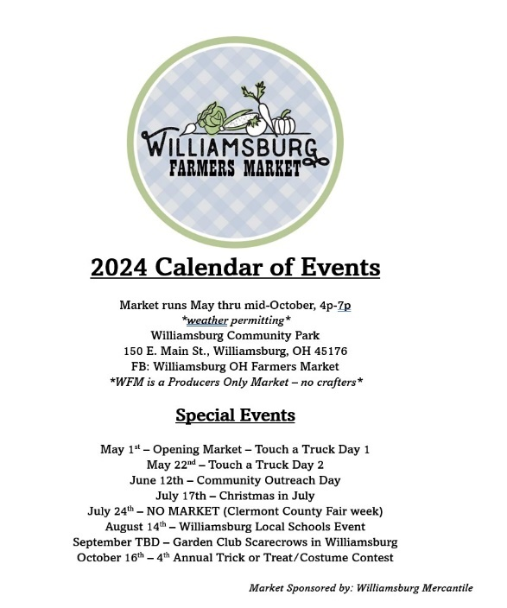 |  | From the Clerk of Court  If you need to pay a traffic ticket we have a new convenient way to pay go to: https://www.ohioticketpayments.com/Williamsburg/DocketSearch.php . If you are trying to get your Driver’s License back call or email the Clerk of Court, we are here to help! (513) 724-6107 or courtclerk@williamsburgohio.org  Zoning and Housing Code  Williamsburg has both a Zoning Code and a Housing Code that require certain levels of property maintenance. Some of the items that are required are as follows:  Grass Ordinance 1199-22  Grass must not exceed 12 inches and must be cut per the ordinance. Only one notice per calendar year.  Other  - Store all items inside your home or an outbuilding, not in the yard or on your porch.  - Vehicles must be road-worthy and licensed.  - Campers must be stored behind the house November 1st to April 1st.  - Homes must be kept in general good repair (siding must be replaced, windows, gutters, roofs repaired as needed, paint, etc.)  Visit www.williamsburgohio.org for “Zoning” or call (513) 724-6107 for any zoning questions or concerns.

